Full Stack Development – Module 3 Answers

1. Components of the MERN Stack and Their Interaction
The MERN stack is a popular JavaScript-based technology stack used for developing full stack web applications.
MERN stands for MongoDB, Express.js, React.js, and Node.js. Each component plays a specific role in handling
different layers of the application.

MongoDB is a NoSQL database that stores application data in JSON-like documents. It is flexible and schema‑less,
allowing developers to store structured as well as semi‑structured data. For example, user information, product
details, and application logs can be stored in MongoDB collections.

Express.js is a lightweight backend web framework that runs on Node.js. It simplifies server-side programming by
providing routing, middleware support, and request handling. Developers use Express to create REST APIs such as
login APIs, product APIs, and data submission endpoints.

React.js is a front-end JavaScript library used to build interactive user interfaces. It follows a component-based
architecture where the UI is divided into reusable components. React manages the view layer and communicates with
the backend using HTTP requests (GET, POST, PUT, DELETE).

Node.js is the runtime environment that allows JavaScript to run on the server. It handles server operations,
processes client requests, and connects the frontend with the database.

Interaction Flow:
1. The user interacts with the React frontend.
2. React sends an API request to the Express/Node server.
3. The server processes the request and communicates with MongoDB.
4. MongoDB returns data to the server.
5. The server sends the response back to React, which updates the UI.
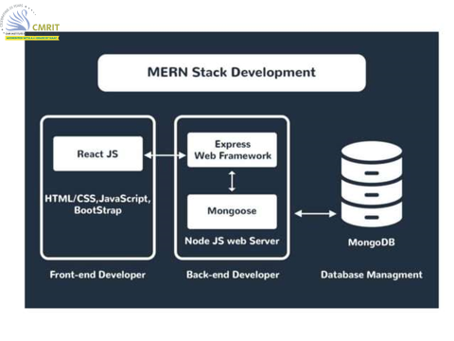

Example: In an online shopping application, React displays products, Express handles order requests, Node runs the
server logic, and MongoDB stores user orders and product details.

2. How React Uses JSX for Rendering UI Components
JSX (JavaScript XML) is a syntax extension used in React that allows developers to write HTML-like code inside
JavaScript. JSX makes it easier to design UI components because the structure of the interface becomes more
readable and expressive.

React converts JSX into standard JavaScript using a compiler such as Babel. Internally, JSX becomes
React.createElement() calls which generate virtual DOM elements.

Benefits of JSX:
1. Improved readability – Developers can easily understand UI structure.
2. Faster development – Writing HTML-style syntax inside JavaScript reduces complexity.
3. Component-based design – JSX helps organize UI into reusable components.
4. Better error detection – Compilation errors appear early during development.
5. Prevents injection attacks – JSX automatically escapes values to improve security.

Example:
Instead of writing:
React.createElement("h1", null, "Hello Student")

Using JSX:
<h1>Hello Student</h1>

Thus, JSX simplifies UI development, improves maintainability, and enhances productivity in React applications.

3. Serverless Hello World – Explanation
<!DOCTYPE HTML>
<html>

<head>
<meta charset="utf-8">
<title>Pro MERN Stack</title>

<script src="https://unpkg.com/react@16/umd/react.development.js"></script>
<script src="https://unpkg.com/react-dom@16/umd/react-dom.development.js"></script>
</head>

<body>

<div id="contents"></div>

<script>
const element = React.createElement(
'div',
{ title: 'Outer div' },
React.createElement('h1', null, 'Hello World!')
);

ReactDOM.render(element, document.getElementById('contents'));
</script>

</body>

</html>

